Boyles Law
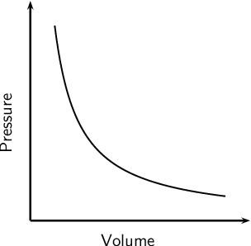
- As Volume is Doubled pressure is halved
- Liters
- ATM
- Inversly Proportional

Charles Law
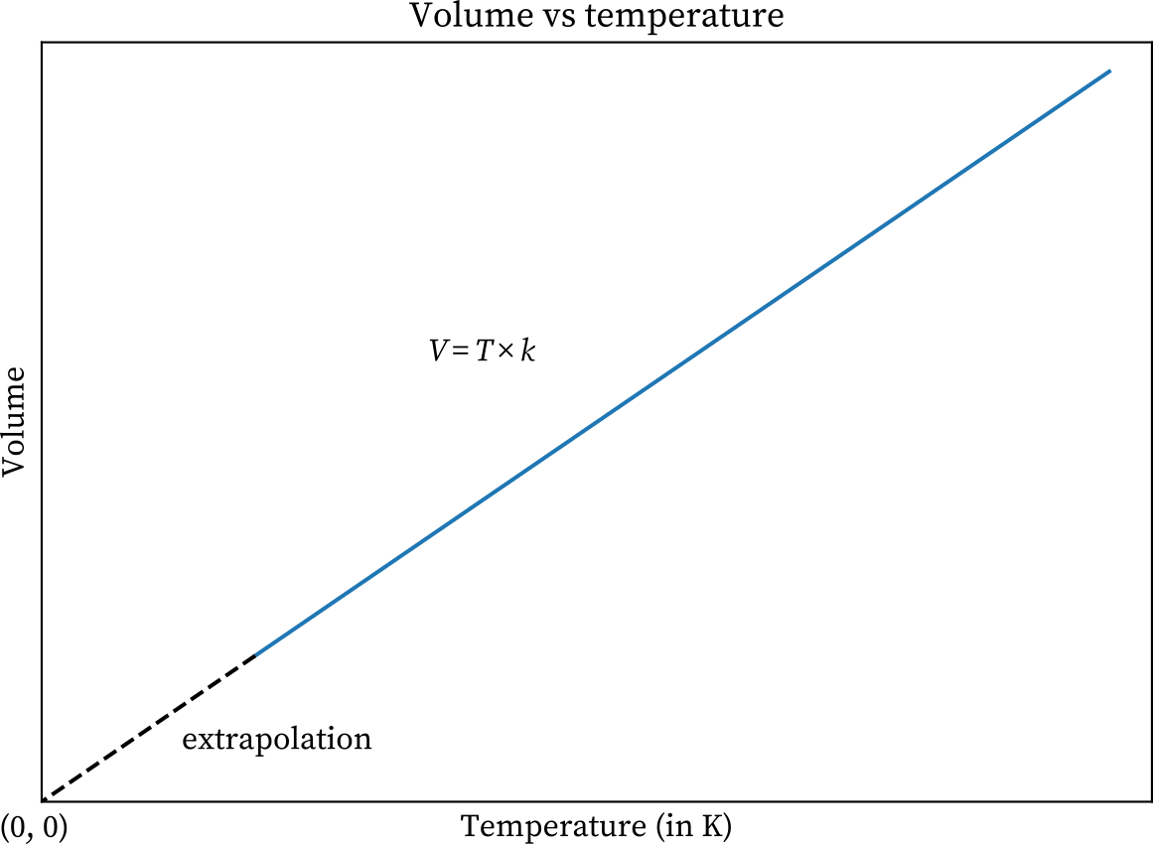
- As Volume is doubled Temperature is doubled
- Kelvin
- Directly Proportional

ALL TEMPERATURES IN GAS LAWS MUST BE IN KELVIN

KELVIN IS 273.15

